**Drupal 8 Rest Setup**

1. To setup Rest we need to enable some modules which is already there in Drupal8

List of module-

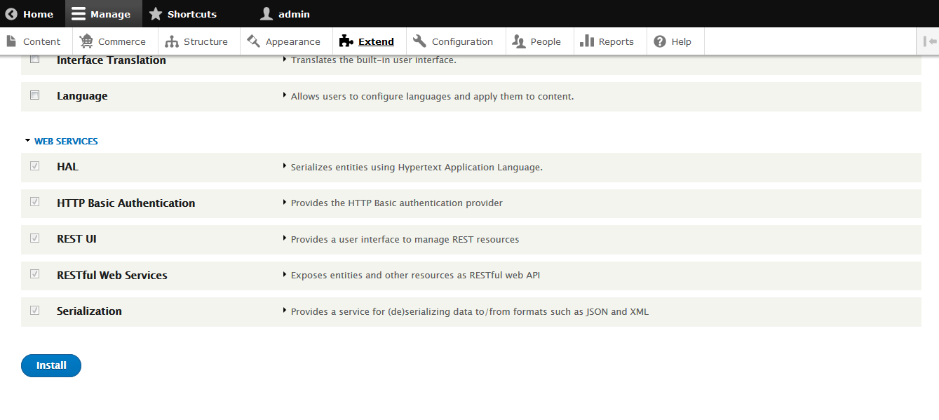

1. To call web services we need to enable GET and POST method form configuration -> web services -> REST

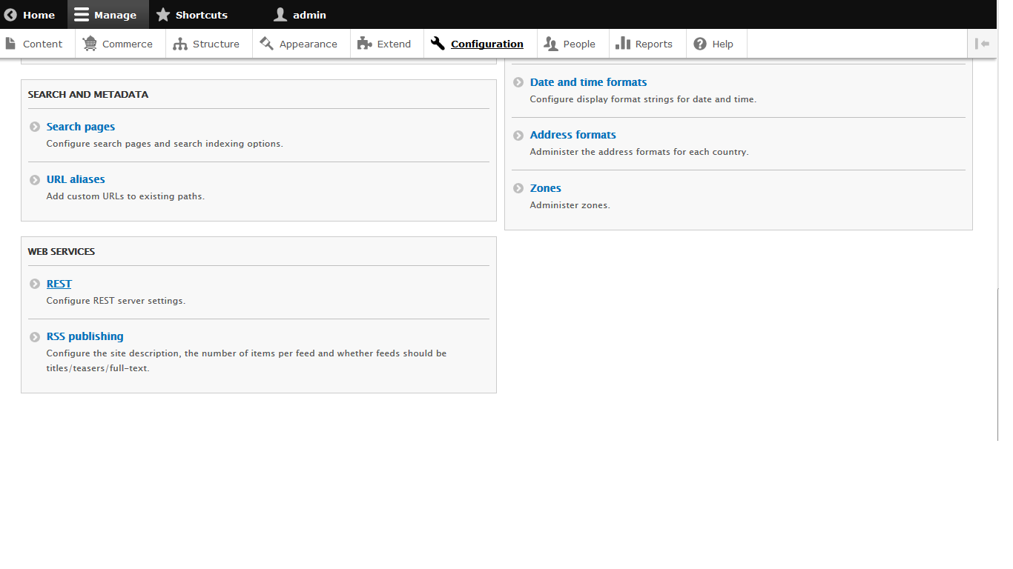

1. We need to enable Content

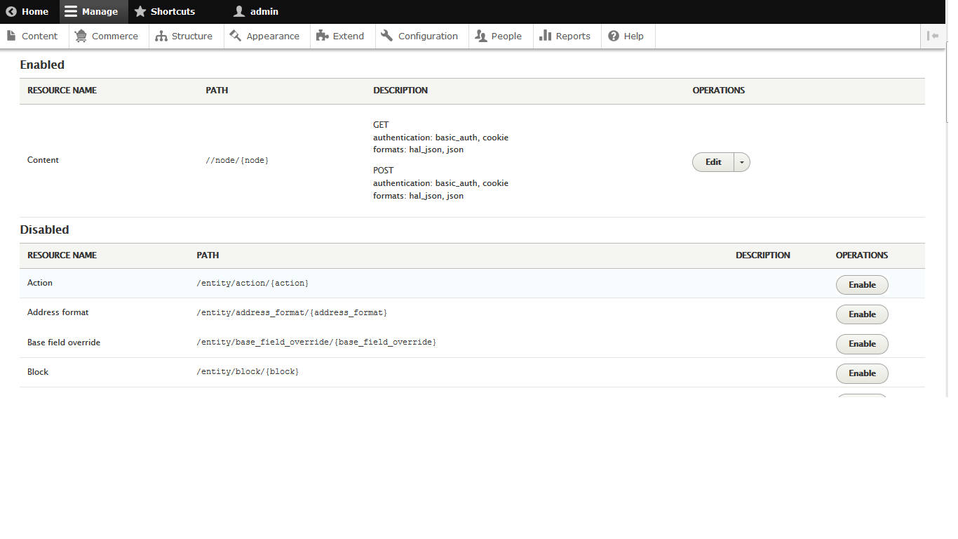

1. Edit content type to set Get and Post Method with following content type and Authentication provider

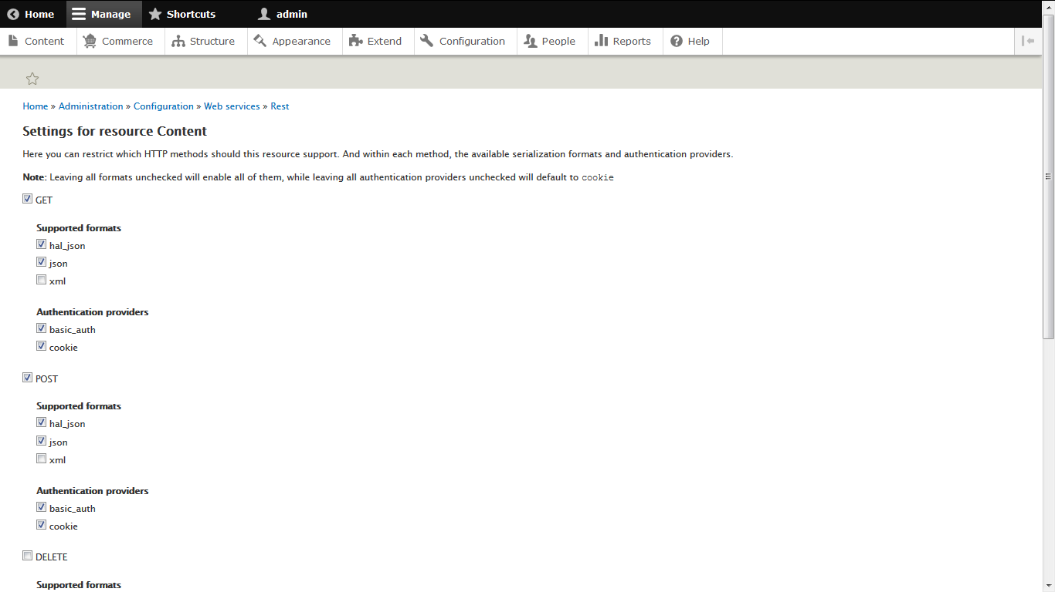

1. Set permission for J&J page to create and display content accordingly

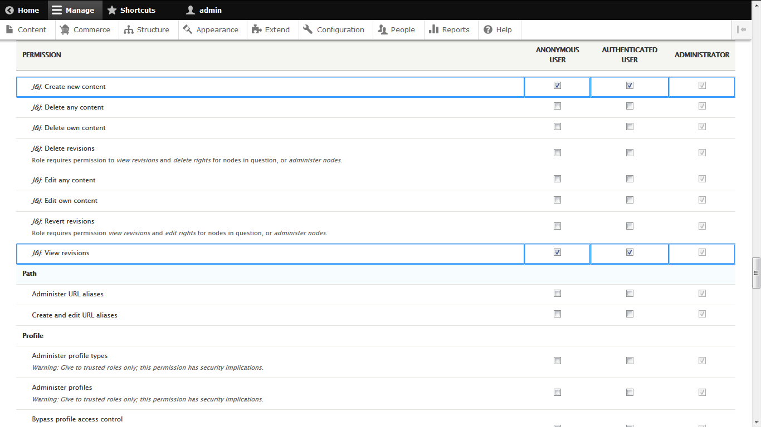

1. Also set permission for RESTful web services

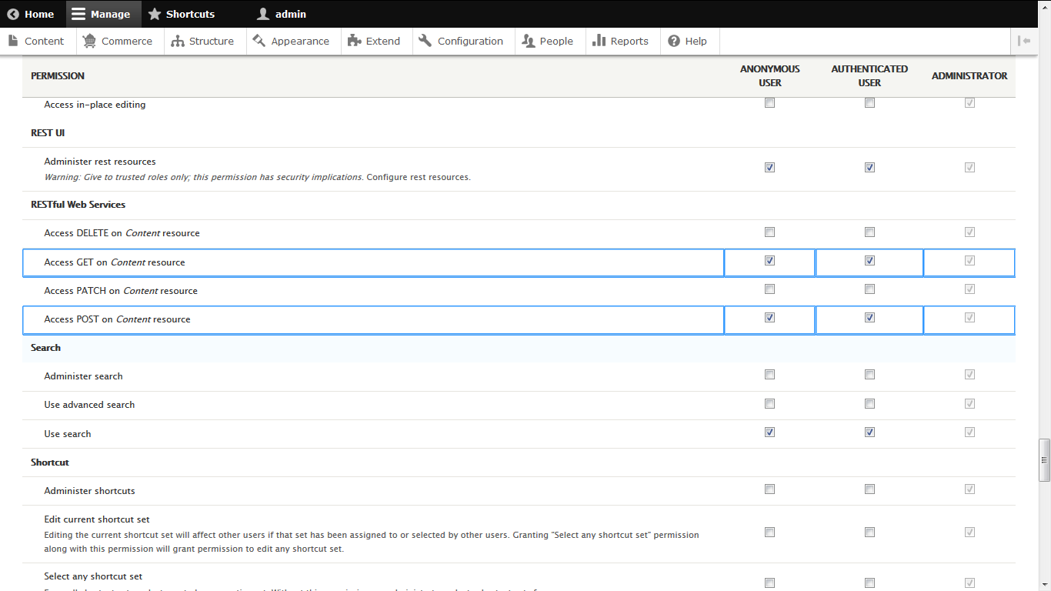

1. Download DHC rest client for chrome in order to execute rest api .

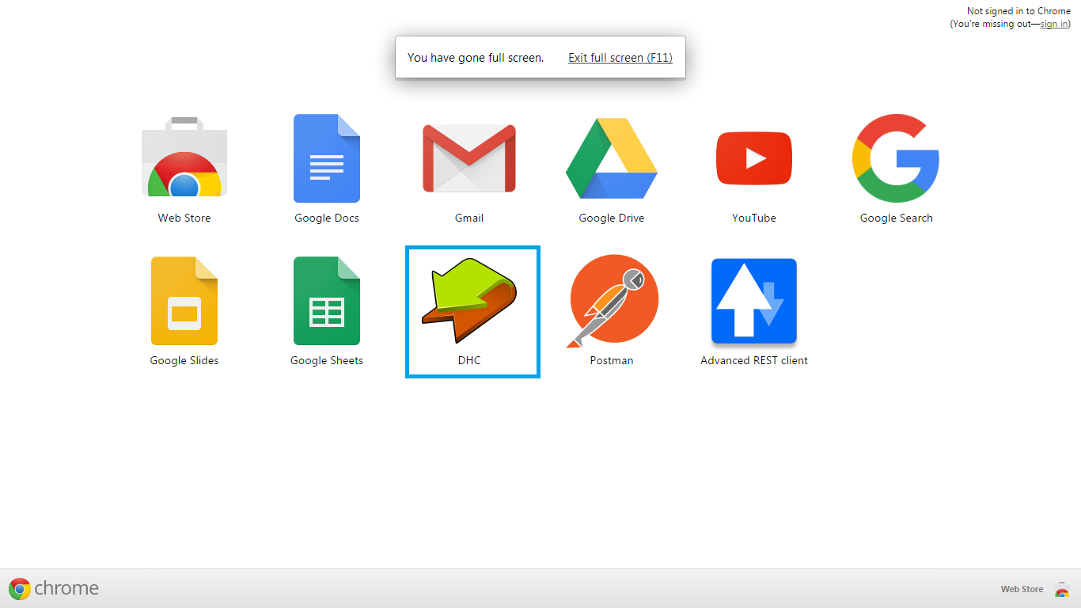

1. Do following setup in your client (DHC) to POST content using content resource.

Content Resource path:

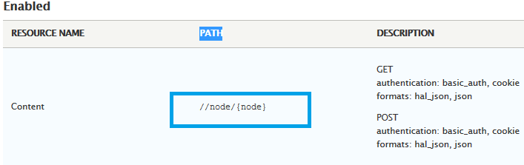

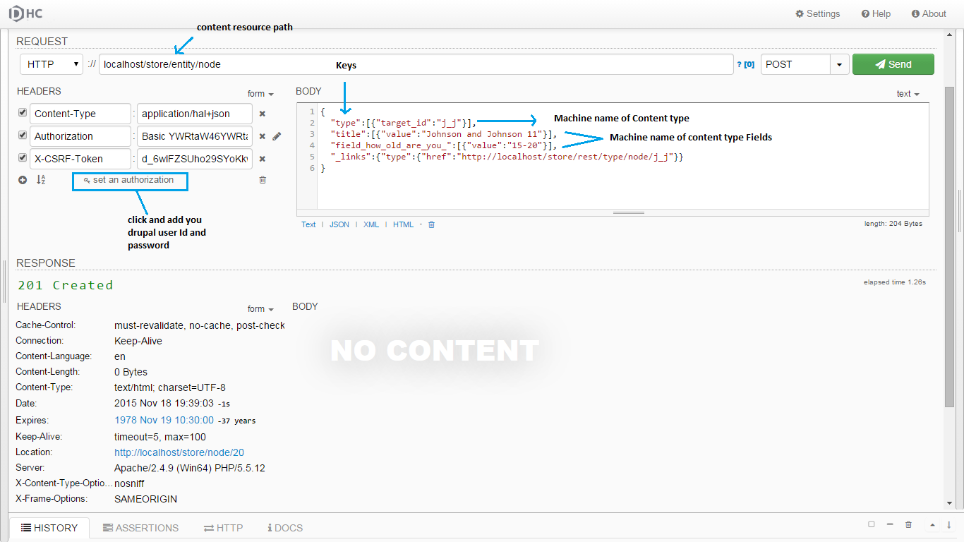

1. To set Header and Body (refer image above) please follow steps below:
2. Content-type : application/hal+json
3. Authorization will be you drupal user id and password (this you can set by just click on set an authorization and provide your id and password)
4. X-CSRF-Token is required visit here (<http://localhost/d8/rest/session/token> )
5. To create drupal content use json data(below) paste it into body text-area (refer above).
6. Key refers to content fields

{

"type":[{"target_id":"j_j"}],

"title":[{"value":"Johnson and Johnson 10"}],

"field_how_old_are_you_":[{"value":"15-20"}],

"_links":{"type":{"href":"http://localhost/store/rest/type/node/j_j"}}

}

1. Do following setup in your client (DHC) to GET content using content resource path.

